# Functions vocabulary

Relation:

Domain:

Range:

We can represent a relation as a set of ordered pairs, a table, a map, a graph, or an equation.

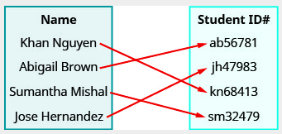

MAPPING

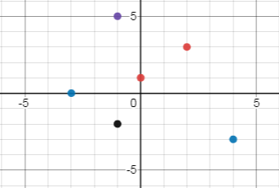

GRAPH

Examples: Determine the domain and range of each relation.

1) $\{\left(1, 3\right), \left(2, 6\right), \left(3, 9\right), \left(4, 12\right), (5, 15)\}$

2)

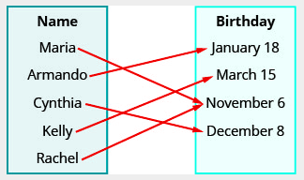

3)

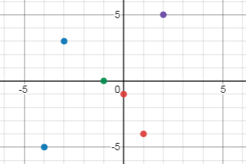

# Function definition

A **function** is a relation in which each possible input value leads to exactly one output value.

Example: The following figure compares relations that are functions and relations that are not functions. Explain why each figure is or is not a function and give your reasoning.

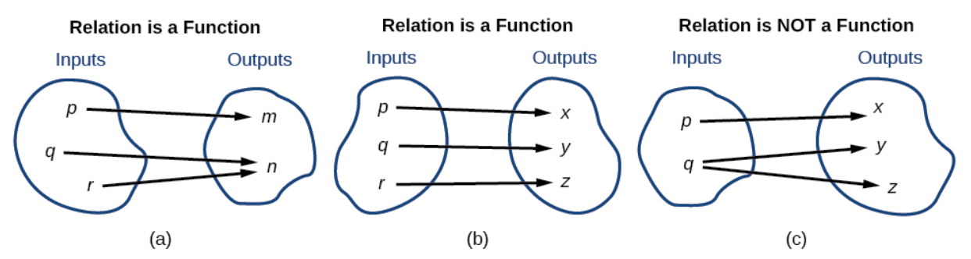

# To determine if a relation is a function:

1)

2)

3)

Example: Determine if each relation is a function. Explain why it is or is not a function.

1)

2) 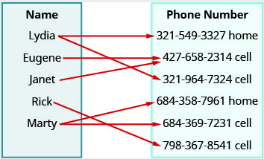

3)

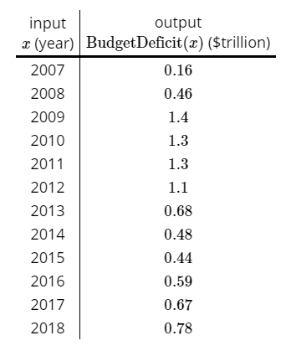

# Determining if an equation is a function

To determine if an equation represents a function, we must solve for $y$. If each value of $x$ results in only one value of $y$, then the equation defines a function. We say, $y$ is a function of $x$.

Example: Determine if each equation represents a function.

1) $2x+y=7$

2) $y=x^{2}+1$

3) $x+y^{2}=7$

# Vertical Line Test

If any vertical line intersects a graph more than once, then the graph does not define a function because a function has only one output value for each input value.

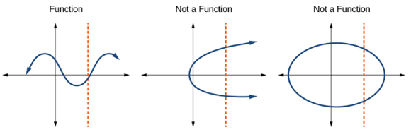

Example: Circle the graphs that represent functions.

